**USER MANUAL**

**HOW TO BUILD**

**1. Registration:**

1. Go to configurations and add a SIP account.

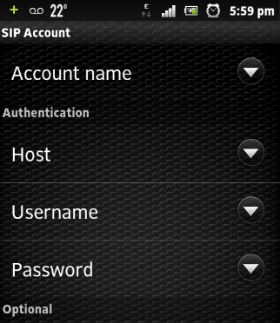

1. Add an account name, domain server, Host credentials.

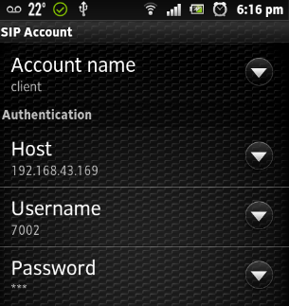

1. Save the details.

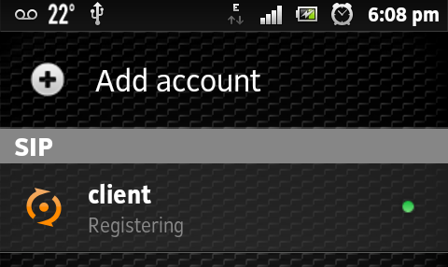 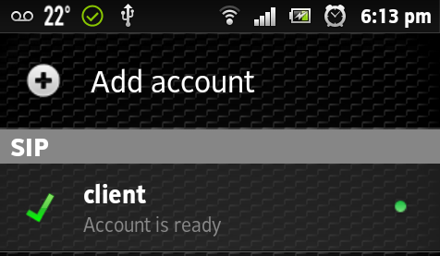

1. **Placing and accepting a call**

|  |  |
| --- | --- |
| To place a call- Dial the extension of the | Accepting a call. |
|  |  |

1. **Sending SMS:**

Go to the chat tab and type your message in chat window and send.



1. **Enabling SRTP on client side.**

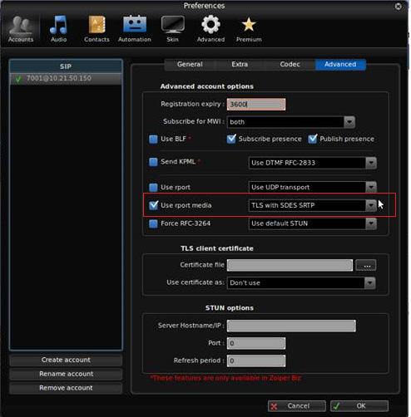

For enabling SRTP Go to advanced settings and check the use report media checkbox and select TLS with SDES SRTP.

1. **Implementing SSL/TLS and Adding certificate.**

For Uploading TLS client certificate go to advanced settings under TLS client certificate upload the certificate by browsing it from the required location.

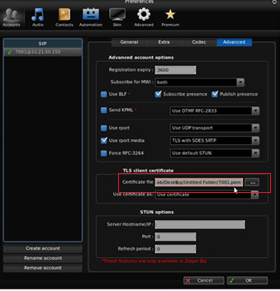

To upload CA certificate go to advanced settings Tab in enter CA certificate browse the certificate from the system and upload it.

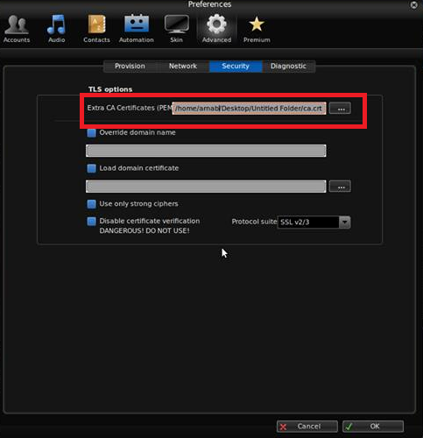

**HOW TO BUILD**

* **How to configure server:**

To install Asterisk into a Linux machine, first, we need to install few dependencies:

> DAHDI -- DAHDI (Digium /Asterisk Hardware Device Interface) is the open source device interface technology used to control Digium and other legacy telephony interface cards.

* **Code to install DAHDI -**

$ tar zxvf dahdi-linux-complete*

$ cd /usr/src/dahdi-linux-complete*

$ make && make install && make config

* **To start DAHDI -**

$ /etc/init.d/dahdi start

> Libpri -- LIBPRI is an open source library that encapsulates the protocols used to communicate over ISDN Primary Rate Interfaces.

* **Code to install libpri –**

$ tar zxvf libpri*

$ cd /usr/src/libpri*

$ make && make install

After the dependencies are installing, we install Asterisk server.

* **Code to install Asterisk -**

$ tar zxvf asterisk*

$ cd /usr/src/asterisk*

$ ./configure && make menuselect && make && make install && make config && make samples

* **To start Asterisk -**

$ /etc/init.d/asterisk start

$ asterisk –rvvv

* **Configure sip.conf -**

(take from source code folder) at /etc/asterisk/etc.conf

* **Configure extensions.conf-**

(take from source code folder) at /etc/asterisk/extensions.conf

* **Configure voicemail.conf-**

(take from source code folder) at /etc/asterisk/voicemail.conf

* **For prevent Brute force-**

Run script named Fail2ban.sh

* **For TLS/SSL-**

Run script ast_tls_cert

* **For geographical restriction-**

Run script Country.restrict.iptables.sh